|  |  |
| --- | --- |
| **Project title** | **TETRIS** |
| **Author(s)** | **Pop Rareș-Andrei** |
| **Group** | **30424** |

# Task Description

This project is an implementation of the famous puzzle game Tetris, created in 1985 by Alexey Pajitnov. In Tetris, the player has to complete lines by moving and rotating differently shaped pieces called tetrominoes. Once a line (or more) is completed, they disappear and give the player points and thus more space to build. The more lines are cleared at once, the more scorepoints will be awarded to the player. The game is over when the uncleared lines reach the top of the screen. 5 seconds after the player lost the game, the window will close automatically. The longer the player can delay this outcome, the higher their score will be.

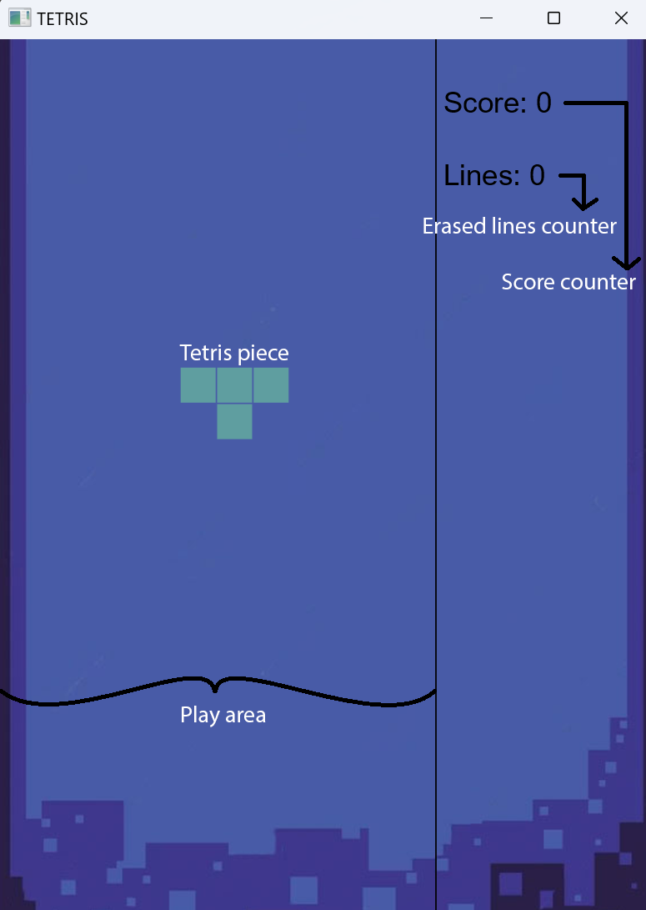

To play the game, the user has to use the arrow keys on the keyboard. Press left arrow key to move the piece to the left, the right arrow key to move the piece to the right, the down arrow key to make the piece fall faster and the up arrow key to rotate the piece.

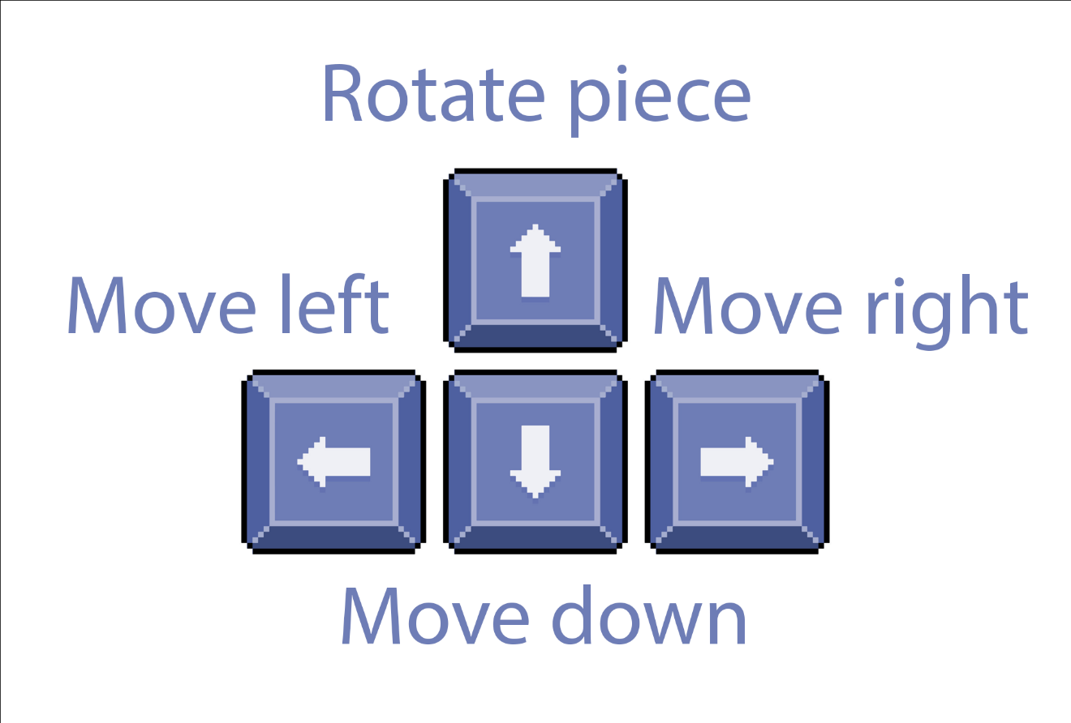

The game works by having a MESH of Rectangles initialized with value 0. All shapes are composed of 4 rectangles we named a,b,c and d arranged in various ways. Every time a piece reaches a lower limit, we check if there were any complete lines created and if yes we delete them and move all the uncompleted lines above the completed lines downwards if there are any.

# Class Discovery.

|  |  |
| --- | --- |
| **Launcher** | |
| **Responsabilities** | **Collaborator classes** |
| Contain the main method to launch the Tetris Application | Tetris: the main class of the Tetris application that extends ‘Application’ |

|  |  |
| --- | --- |
| **Tetris** | |
| **Responsabilities** | **Collaborator classes** |
| Manage the overall Tetris game, including the game loop, scoring, and user input handling | Pane: JavaFX container used for managing graphical components  Timer and TimerTask -> used for implementing the game loop  Controller: handles user input and shape movement |
| Display the newly created shapes | Shape: contains the representation of the shapes |
| Delete completed rows | Rectangle: Basic building block for creating Tetris shapes |

|  |  |
| --- | --- |
| **Controller** | |
| **Responsabilities** | **Collaborator classes** |
| Control the movement of Tetris shapes (left, right, rotate, check if it can rotate) | Tetris: Provides access to game parameters like grid size and mesh |

|  |  |
| --- | --- |
| **Shape** | |
| **Responsabilities** | **Collaborator classes** |
| Represent a Tetris shape using four rectangles (a, b, c, d), store and manage colors of the Tetris shape, keep track of the current rotation of the Tetris shape | Rectangle -> Basic building block for creating Tetris shapes  Color: Used for specifying the color of the Tetris shape |

# Class Diagram

